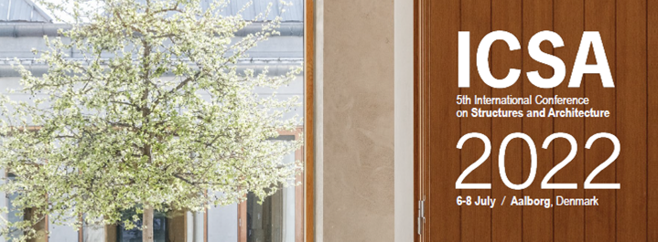

Special Session Proposal Form

If you wish to organize a Special Session at ICSA2022, please send your proposal, containing the following information, to the conference organizers at secretariat@icsa2022.com by September 15, 2020.

Please do not forget to attach to this form the “Terms and Conditions” Signed

Title (not more than 20 words)

Coordinator
Name:
Affiliation:
Email:
Address:
CV
Photo

Description (not more than 100 words)

Speaker 1
Presentation title:
Name:
Affiliation:
Email:
Address:

Speaker 2
Presentation title:
Name:
Affiliation:
Email:
Address:

Speaker 3
Presentation title:
Name:
Affiliation:
Email:
Address:

Speaker 4
Presentation title:
Name:
Affiliation:
Email:
Address:

Speaker 5
Presentation title:
Name:
Affiliation:
Email:
Address:

Speaker 6
Presentation title:
Name:
Affiliation:
Email:
Address:

