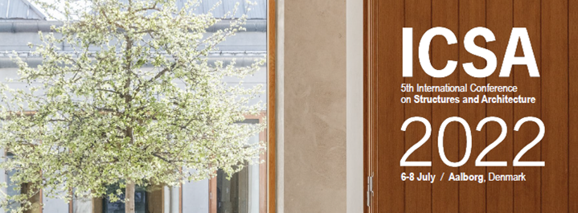

Mini-Symposium Proposal Form

If you wish to organize a Mini-Symposium at ICSA2022, please send your proposal, containing the following information, to the conference organizers at secretariat@icsa2022.com by September 15, 2020.

Please do not forget to attach to this form the “Terms and Conditions” signed

Mini-symposium title (not more than 20 words)

Coordinator
Name:
Affiliation:
Email:
Address:
CV | Please attach to this form a short CV
Photo | Please attach to this form a photo in jpeg format (180x180) pixels

Co-Coordinator
Name:
Affiliation:
Email:
Address:
CV | Please attach to this form a short CV
Photo | Please attach to this form a photo in jpeg format (180x180) pixels

Description (not more than 100 words)

Session 1 title (not more than 10 words)

Speaker 1
Presentation title:
Name:
Affiliation:
Email:
Address:

Speaker 2
Presentation title:
Name:
Affiliation:
Email:
Address:

Speaker 3
Presentation title:
Name:
Affiliation:
Email:
Address:

Speaker 4
Presentation title:
Name:
Affiliation:
Email:
Address:

Speaker 5
Presentation title:
Name:
Affiliation:
Email:
Address:

Speaker 6
Presentation title:
Name:
Affiliation:
Email:
Address:

Session 2 title (not more than 10 words)

Speaker 1
Presentation title:
Name:
Affiliation:
Email:
Address:

Speaker 2
Presentation title:
Name:
Affiliation:
Email:
Address:

Speaker 3
Presentation title:
Name:
Affiliation:
Email:
Address:

Speaker 4
Presentation title:
Name:
Affiliation:
Email:
Address:

Speaker 5
Presentation title:
Name:
Affiliation:
Email:
Address:

Speaker 6
Presentation title:
Name:
Affiliation:
Email:
Address:

Session 3 title (not more than 10 words)

Speaker 1
Presentation title:
Name:
Affiliation:
Email:
Address:

Speaker 2
Presentation title:
Name:
Affiliation:
Email:
Address:

Speaker 3
Presentation title:
Name:
Affiliation:
Email:
Address:

Speaker 4
Presentation title:
Name:
Affiliation:
Email:
Address:

Speaker 5
Presentation title:
Name:
Affiliation:
Email:
Address:

Speaker 6
Presentation title:
Name:
Affiliation:
Email:
Address:

Session 4 title (not more than 10 words)

Speaker 1
Presentation title:
Name:
Affiliation:
Email:
Address:

Speaker 2
Presentation title:
Name:
Affiliation:
Email:
Address:

Speaker 3
Presentation title:
Name:
Affiliation:
Email:
Address:

Speaker 4
Presentation title:
Name:
Affiliation:
Email:
Address:

Speaker 5
Presentation title:
Name:
Affiliation:
Email:
Address:

Speaker 6
Presentation title:
Name:
Affiliation:
Email:
Address:

Session 5 title (not more than 10 words)

Speaker 1
Presentation title:
Name:
Affiliation:
Email:
Address:

Speaker 2
Presentation title:
Name:
Affiliation:
Email:
Address:

Speaker 3
Presentation title:
Name:
Affiliation:
Email:
Address:

Speaker 4
Presentation title:
Name:
Affiliation:
Email:
Address:

Speaker 5
Presentation title:
Name:
Affiliation:
Email:
Address:

Speaker 6
Presentation title:
Name:
Affiliation:
Email:
Address:

